CHAPTER 19
Chemical Coordination and Integration

The neural system provides a point-to-point rapid coordination among organs. The neural coordination is fast but short-lived.
As the nerve fibres do not innervate all cells of the body and the cellular functions need to be continuously regulated, a special kind of coordination and integration has to be provided. This function is carried out by hormones.
The neural system and the endocrine system jointly coordinate and regulate the physiological functions in the body.
Chapter 19 map | What it covers
19.1 Endocrine Glands and Hormones | What a ductless gland and a hormone are
19.2 Human Endocrine System | The ten glands in fixed order: hypothalamus, pituitary, pineal, thyroid, parathyroid, thymus, adrenal, pancreas, testis, ovary
19.3 Hormones of Heart, Kidney and Gastrointestinal Tract | Hormone sources that are not endocrine glands
19.4 Mechanism of Hormone Action | How a hormone acts once it reaches its target

[MEMORY AID - not in NCERT] Two coordinating systems, two speeds: neural = fast but short-lived and point-to-point; endocrine = slower but sustained and broadcast in the blood. Every fact in this chapter hangs on that contrast.

19.1 | ENDOCRINE GLANDS AND HORMONES

• Endocrine glands lack ducts and are hence called ductless glands. Their secretions are called hormones.
Gland type | Duct | Where the secretion goes
Endocrine (ductless) | Absent | Released as a hormone, carried in the blood
Exocrine | Present | Poured through the duct on to a surface or into a cavity

[NOTE] Exocrine gland - the chapter uses the word without defining it (the pancreas acts as both exocrine and endocrine gland, and secretin acts on the exocrine pancreas), so the contrast is stated here from the chapter's own words only: an endocrine gland is ductless, therefore an exocrine gland is the duct-bearing kind. Nothing beyond that is claimed.

The classical definition of hormone as a chemical produced by endocrine glands and released into the blood and transported to a distantly located target organ has a current scientific definition as follows.
• Hormones are non-nutrient chemicals which act as intercellular messengers and are produced in trace amounts.
The new definition covers a number of new molecules in addition to the hormones secreted by the organised endocrine glands.
• Invertebrates possess very simple endocrine systems with few hormones, whereas a large number of chemicals act as hormones and provide coordination in the vertebrates.
• The human endocrine system is described here.
• These hormones regulate metabolism, growth and development of our organs, the endocrine glands or certain cells.
19.2 | HUMAN ENDOCRINE SYSTEM

• The endocrine glands and hormone producing diffused tissues/cells located in different parts of our body constitute the endocrine system.
Pituitary, pineal, thyroid, adrenal, pancreas, parathyroid, thymus and gonads (testis in males and ovary in females) are the organised endocrine bodies in our body (Figure 19.1). Counting the hypothalamus, the endocrine system is composed of hypothalamus, pituitary and pineal, thyroid, adrenal, pancreas, parathyroid, thymus and gonads (testis and ovary).
In addition to these, some other organs, e.g., gastrointestinal tract, liver, kidney, heart also produce hormones. A brief account of the structure and functions of all major endocrine glands and hypothalamus of the human body is given in the following sections.
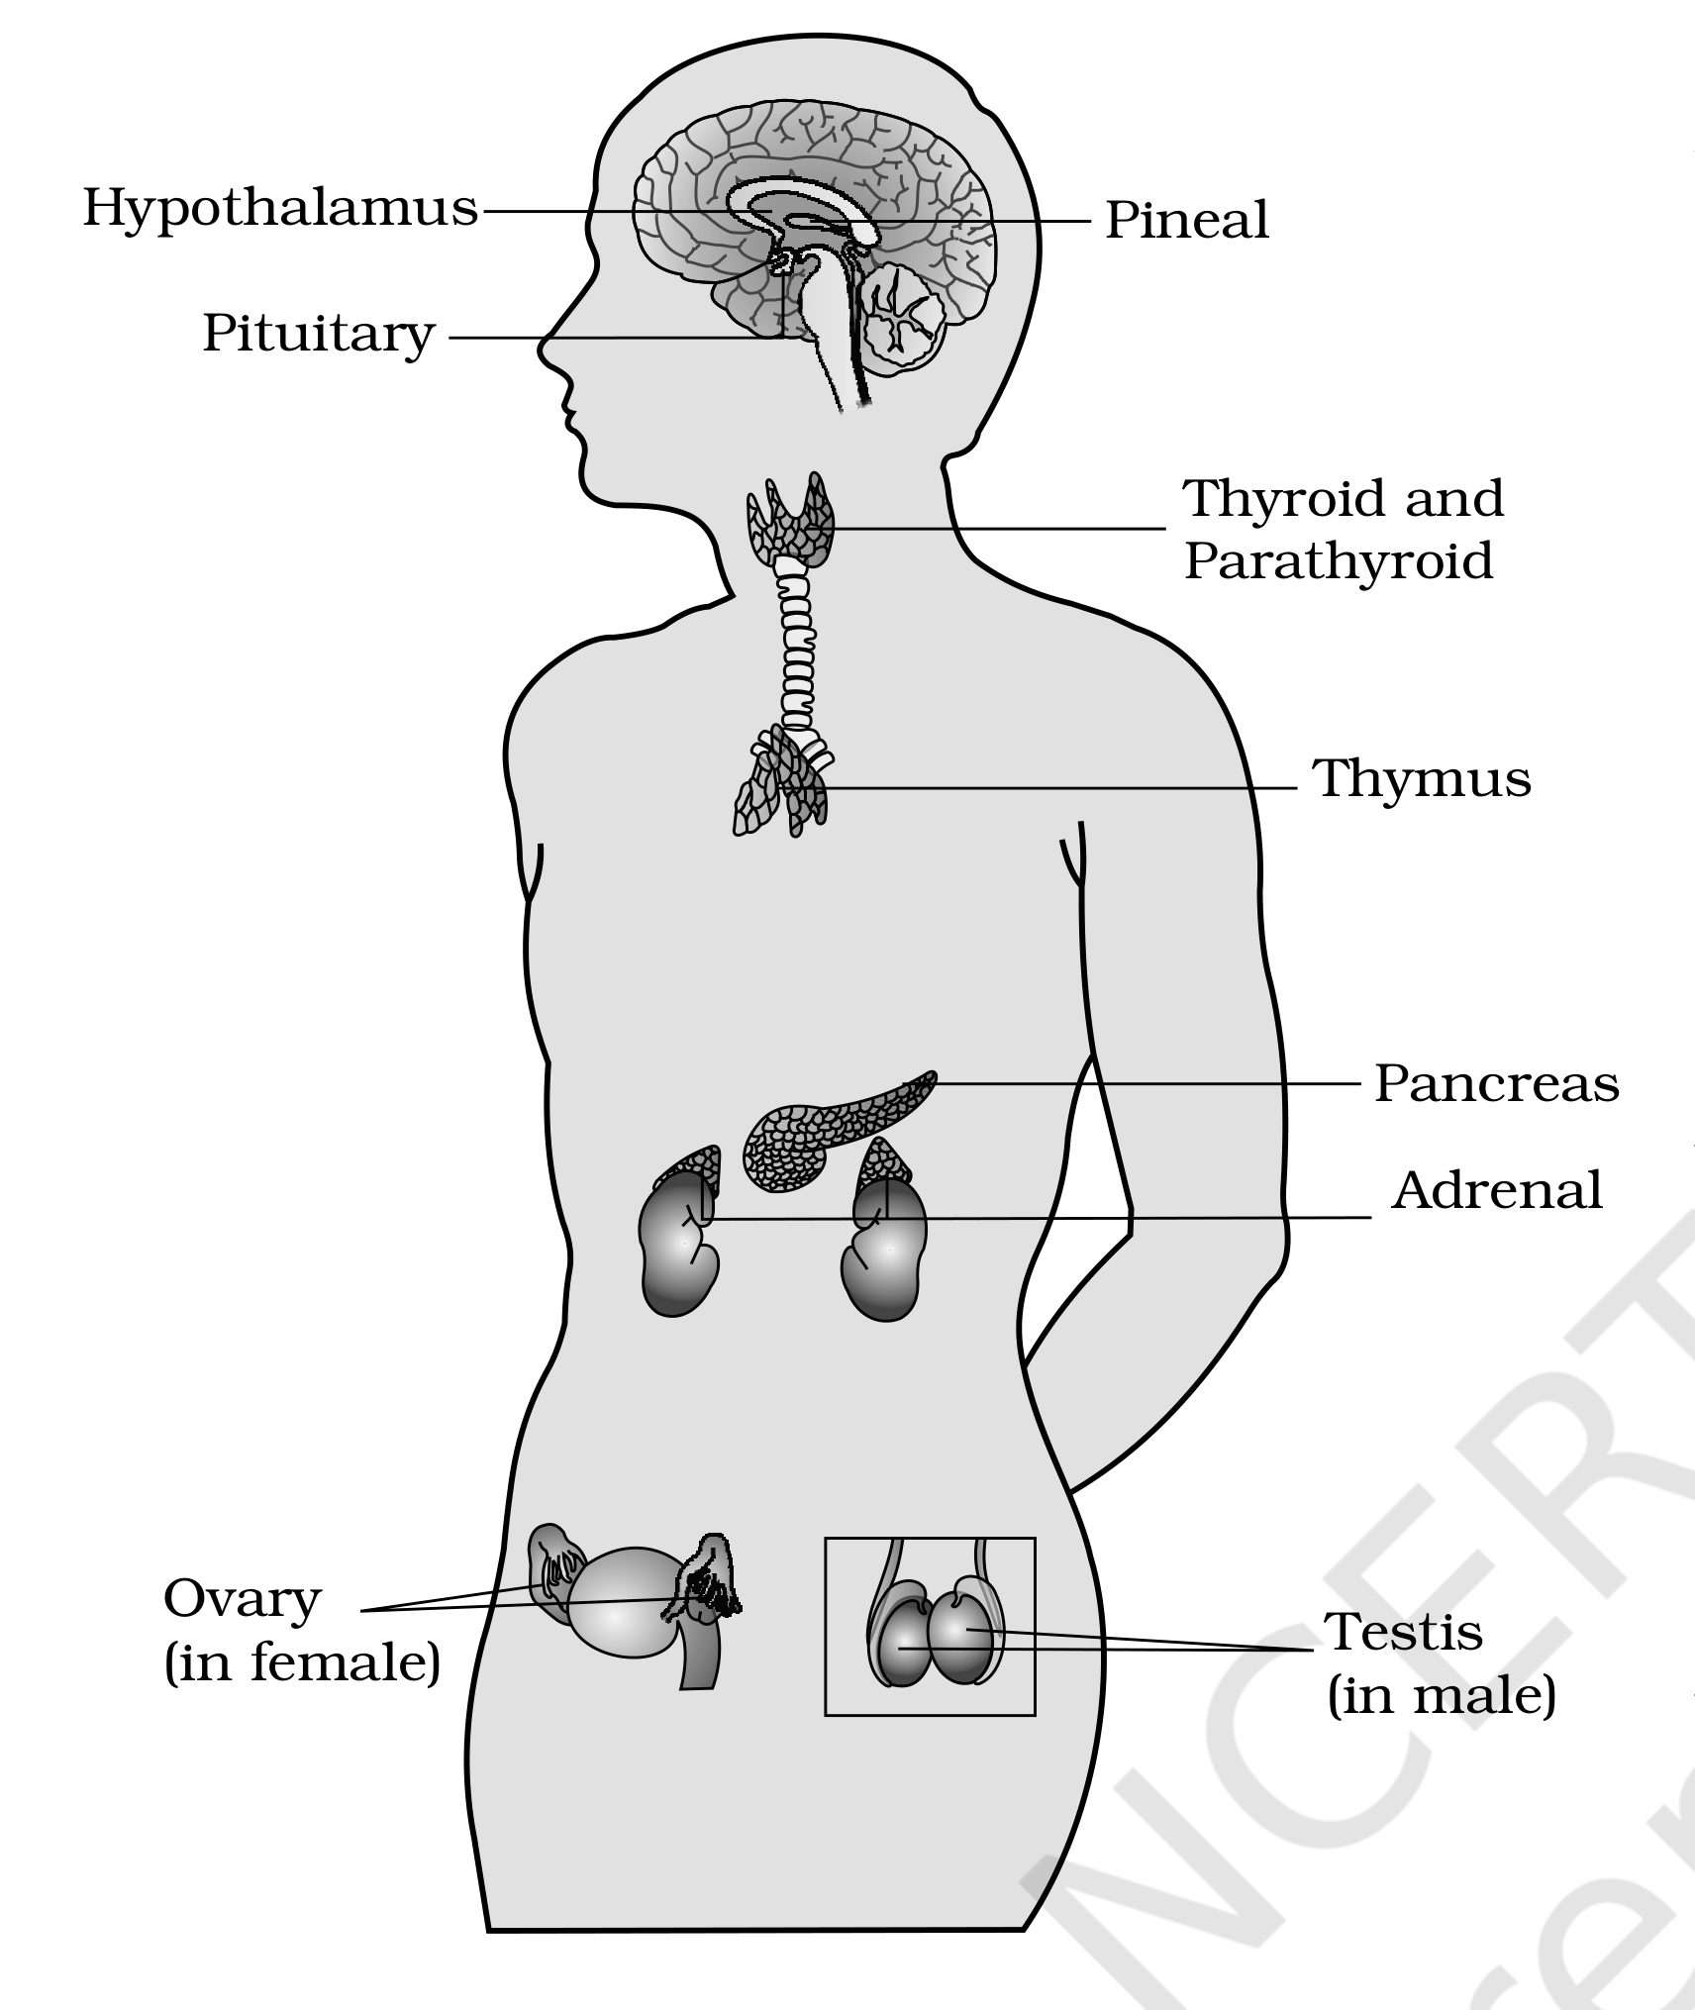
Figure 19.1 Location of endocrine glands
[MEMORY AID - not in NCERT] Ten glands, head to gonad, in the order Section 19.2 uses them: Hypothalamus, Pituitary, Pineal, Thyroid, Parathyroid, Thymus, Adrenal, Pancreas, Testis, Ovary. Learn the order once and every subsection number becomes predictable.

19.2.1 | The Hypothalamus

The hypothalamus is the basal part of diencephalon, forebrain (Figure 19.1) and it regulates a wide spectrum of body functions.
• It contains several groups of neurosecretory cells called nuclei which produce hormones. These hormones regulate the synthesis and secretion of pituitary hormones.
Hypothalamic hormone type | What it does | Example
Releasing hormones | Stimulate secretion of pituitary hormones | Gonadotrophin releasing hormone (GnRH) stimulates the pituitary synthesis and release of gonadotrophins
Inhibiting hormones | Inhibit secretions of pituitary hormones | Somatostatin from the hypothalamus inhibits the release of growth hormone from the pituitary

1 | These hormones originate in the hypothalamic neurons.
2 | They pass through axons and are released from their nerve endings.
3 | They reach the pituitary gland through a portal circulatory system.
4 | There they regulate the functions of the anterior pituitary.

[NOTE] The posterior pituitary is under the direct neural regulation of the hypothalamus (Figure 19.2) - so the two lobes are reached by two different routes: the anterior by blood (portal system), the posterior by nerve.

19.2.2 | The Pituitary Gland

The pituitary gland is located in a bony cavity called sella tursica (the source's own spelling) and is attached to hypothalamus by a stalk (Figure 19.2). It is divided anatomically into an adenohypophysis and a neurohypophysis.
Anatomical division | Part | Hormones
Adenohypophysis - consists of two portions | Pars distalis, commonly called anterior pituitary | Growth hormone (GH), prolactin (PRL), thyroid stimulating hormone (TSH), adrenocorticotrophic hormone (ACTH), luteinizing hormone (LH) and follicle stimulating hormone (FSH) - six trophic hormones
 | Pars intermedia | Secretes only one hormone called melanocyte stimulating hormone (MSH); in humans the pars intermedia is almost merged with pars distalis
Neurohypophysis (pars nervosa) | Also known as posterior pituitary | Stores and releases two hormones, oxytocin and vasopressin, which are actually synthesised by the hypothalamus and are transported axonally to neurohypophysis

[NOTE] The pituitary gland is divided into three major parts, which are called as pars distalis, pars intermedia and pars nervosa. Two of the three (distalis, intermedia) make the adenohypophysis; the third is the neurohypophysis.

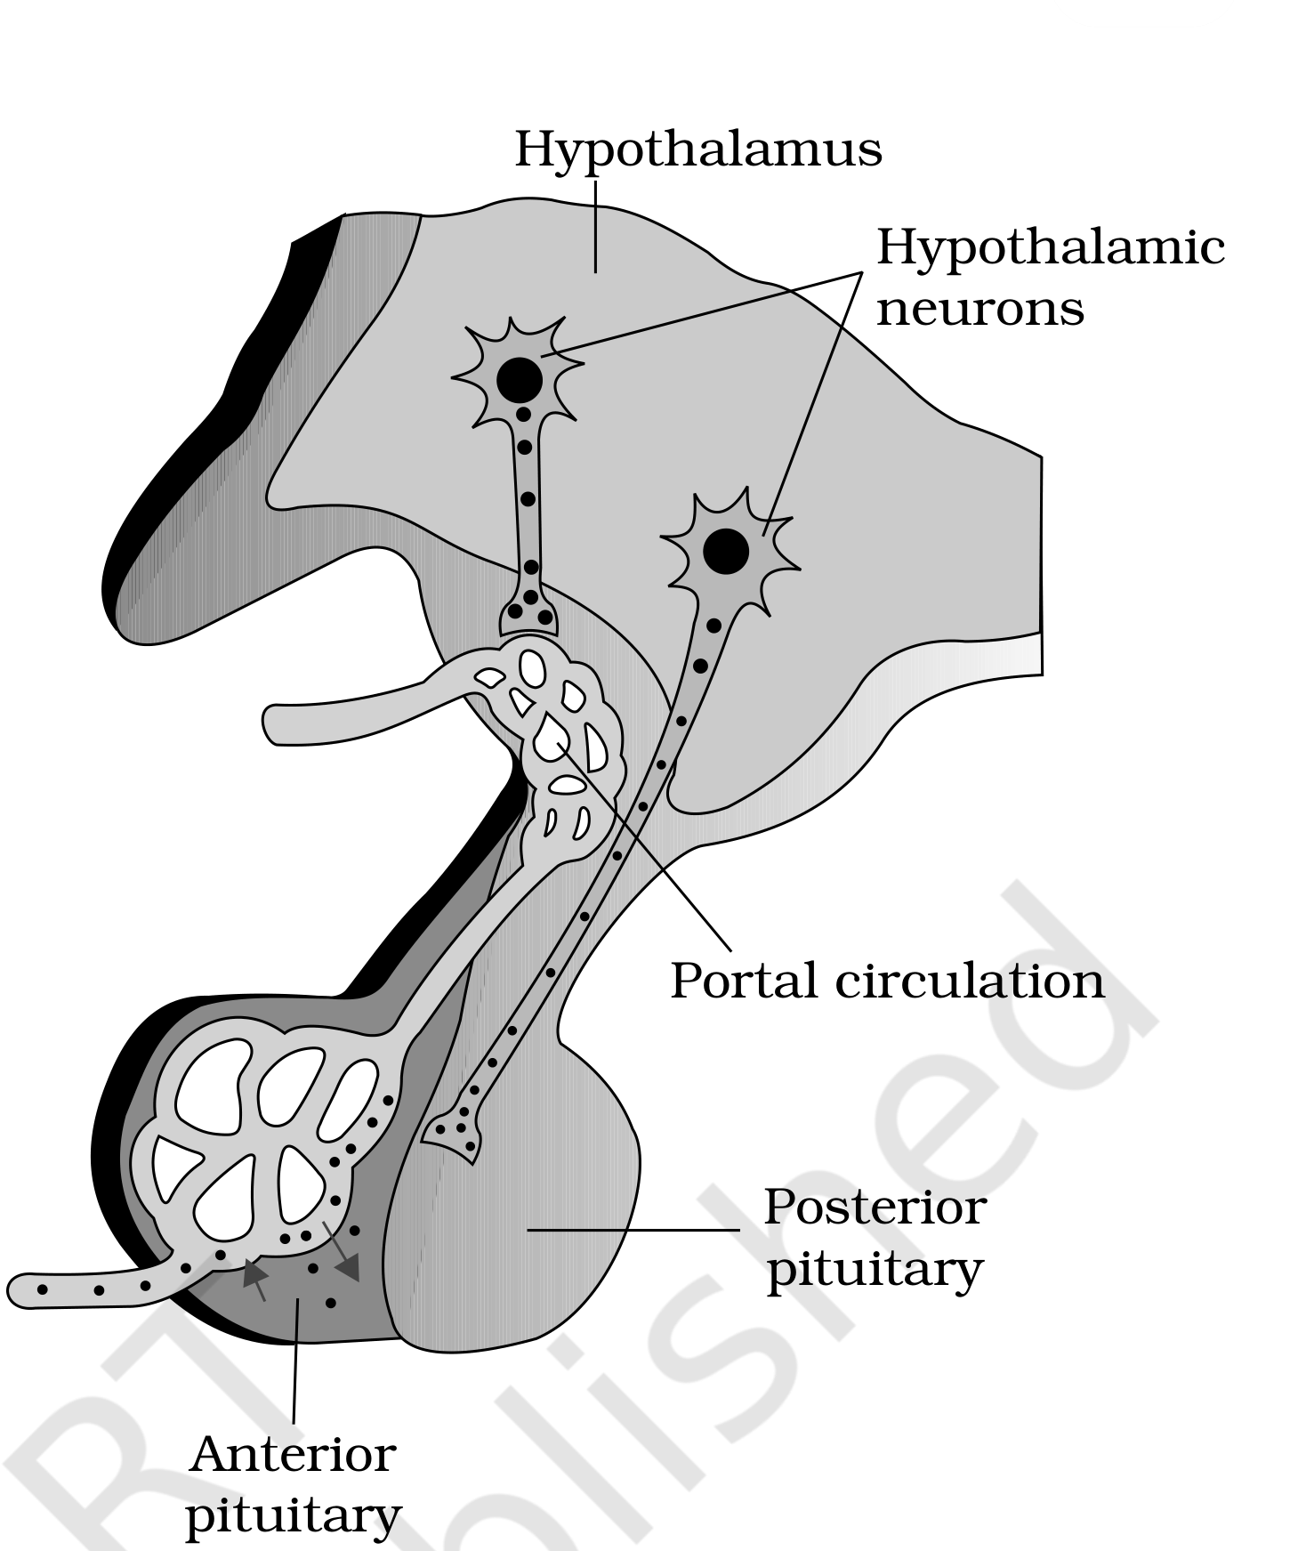
Figure 19.2 Diagrammatic representation of pituitary and its relationship with hypothalamus
Growth hormone (GH) - the two directions of error
Condition | Secretion | Effect
Gigantism | Over-secretion of GH | Stimulates abnormal growth of the body
Pituitary dwarfism | Low secretion of GH | Stunted growth
Acromegaly | Excess secretion of growth hormone in adults, especially in middle age | Severe disfigurement (especially of the face), which may lead to serious complications and premature death if unchecked

[NOTE] Acromegaly is hard to diagnose in the early stages and often goes undetected for many years, until changes in external features become noticeable.

What each anterior-pituitary hormone does
Hormone | Action
Prolactin (PRL) | Regulates the growth of the mammary glands and formation of milk in them
TSH - the exercises call it Thyrotrophin (TSH) | Stimulates the synthesis and secretion of thyroid hormones from the thyroid gland
ACTH - the exercises call it Corticotrophin (ACTH) | Stimulates the synthesis and secretion of steroid hormones called glucocorticoids from the adrenal cortex
LH and FSH | Stimulate gonadal activity and hence are called gonadotrophins
LH in males | Stimulates the synthesis and secretion of hormones called androgens from testis
FSH in males | FSH and androgens regulate spermatogenesis
LH in females | Induces ovulation of fully mature follicles (graafian follicles) and maintains the corpus luteum, formed from the remnants of the graafian follicles after ovulation
FSH in females | Stimulates growth and development of the ovarian follicles
MSH - the exercises call it Melanotrophin (MSH) | Acts on the melanocytes (melanin containing cells) and regulates pigmentation of the skin

The two posterior-pituitary hormones
Hormone | Action
Oxytocin | Acts on the smooth muscles of our body and stimulates their contraction. In females it stimulates a vigorous contraction of uterus at the time of child birth, and milk ejection from the mammary gland
Vasopressin | Acts mainly at the kidney and stimulates resorption of water and electrolytes by the distal tubules, thereby reducing loss of water through urine (diuresis); hence it is also called anti-diuretic hormone (ADH)

[NOTE] An impairment affecting synthesis or release of ADH results in a diminished ability of the kidney to conserve water, leading to water loss and dehydration. This condition is known as Diabetes Insipidus - a water disorder, not a sugar disorder.

Taken together, the pituitary hormones regulate the growth and development of somatic tissues and the activities of peripheral endocrine glands.
[MEMORY AID - not in NCERT] Six from pars distalis: GH, PRL, TSH, ACTH, LH, FSH - "Good People Take All Life's Favours". One from pars intermedia: MSH. Two stored in pars nervosa: oxytocin, vasopressin. 6 + 1 + 2.

19.2.3 | The Pineal Gland

The pineal gland is located on the dorsal side of forebrain. Pineal secretes a hormone called melatonin.
• Melatonin plays a very important role in the regulation of a 24-hour (diurnal) rhythm of our body.
- For example, it helps in maintaining the normal rhythms of sleep-wake cycle, body temperature.
• In addition, melatonin also influences metabolism, pigmentation, the menstrual cycle as well as our defense capability.
19.2.4 | Thyroid Gland

The thyroid gland is composed of two lobes which are located on either side of the trachea (Figure 19.3 a). Both the lobes are interconnected with a thin flap of connective tissue called isthmus.
• The thyroid gland is composed of follicles and stromal tissues. Each thyroid follicle is composed of follicular cells, enclosing a cavity.
These follicular cells synthesise two hormones, tetraiodothyronine or thyroxine (T₄) and triiodothyronine (T₃). Iodine is essential for the normal rate of hormone synthesis in the thyroid.
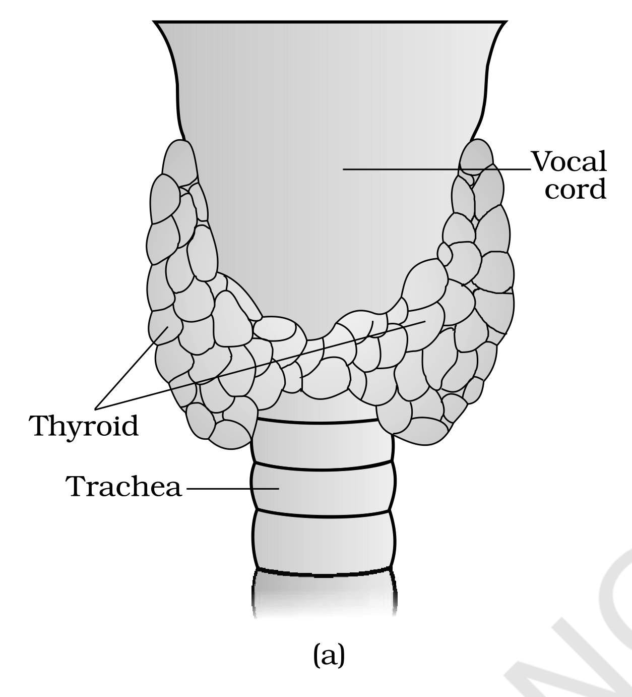
Figure 19.3 Diagrammatic view of the position of Thyroid and Parathyroid (a) Ventral side
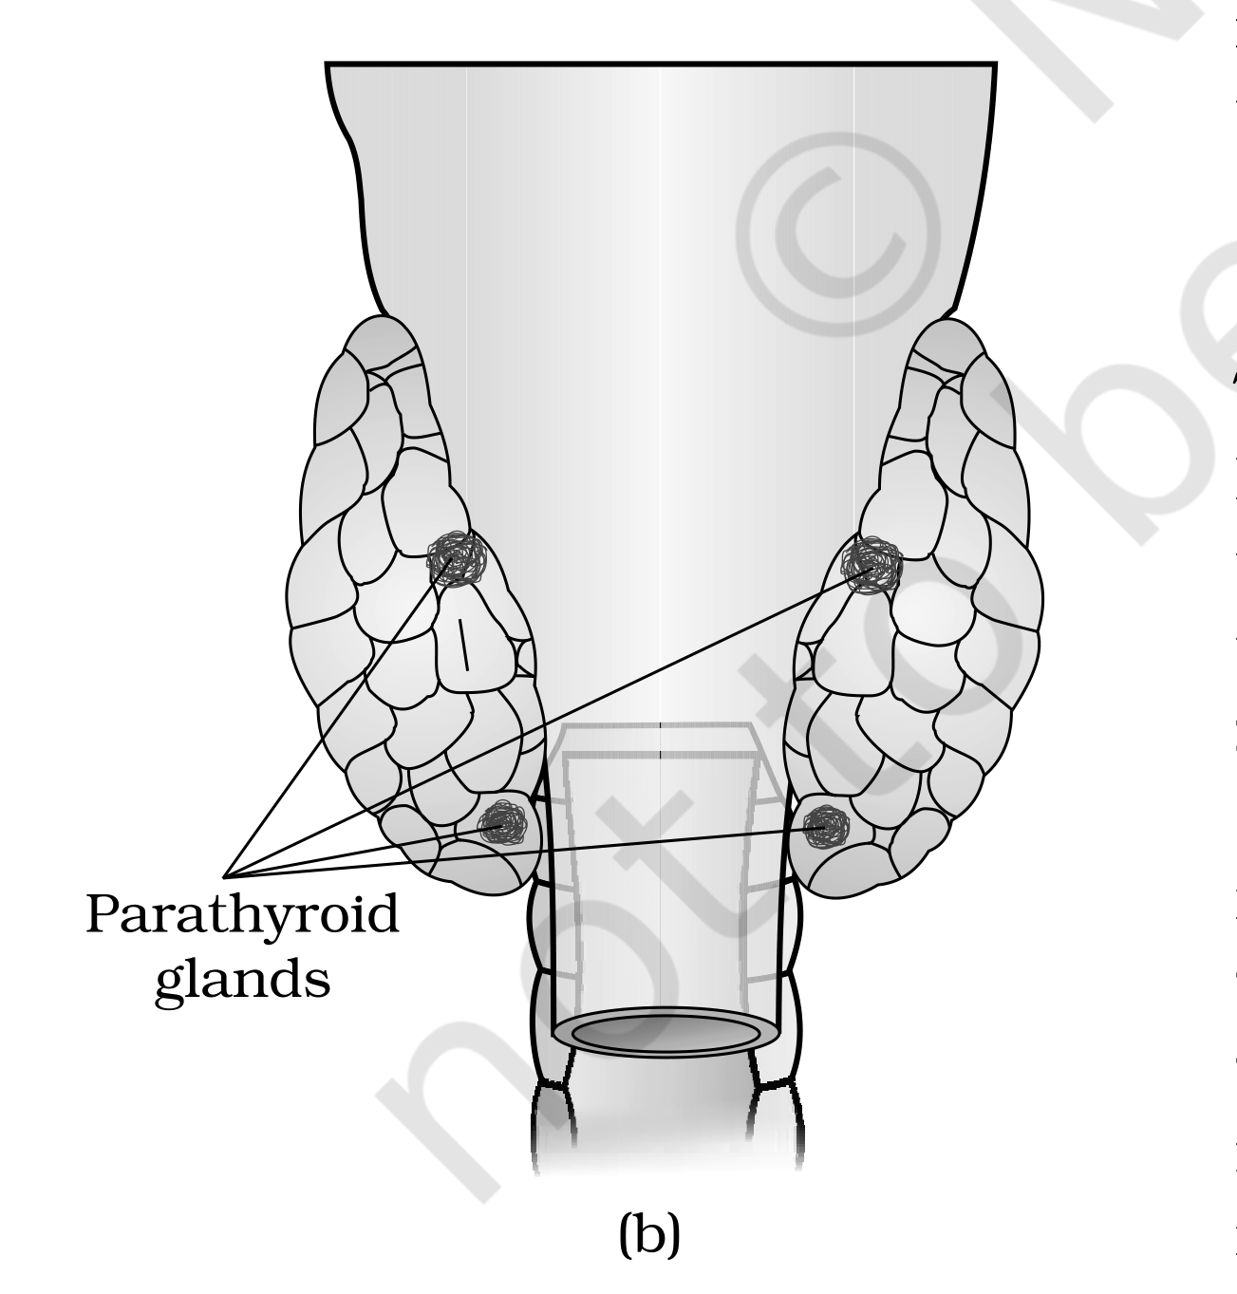
Figure 19.3 Diagrammatic view of the position of Thyroid and Parathyroid (b) Dorsal side
Too little iodine, too much hormone
Disorder | Cause | Consequences
Goitre with hypothyroidism | Deficiency of iodine in our diet | Hypothyroidism and enlargement of the thyroid gland, commonly called goitre
Cretinism | Hypothyroidism during pregnancy | Defective development and maturation of the growing baby leading to stunted growth (cretinism), mental retardation, low intelligence quotient, abnormal skin, deaf-mutism, etc.
Irregular cycle | Hypothyroidism in adult women | The menstrual cycle may become irregular
Hyperthyroidism | Cancer of the thyroid gland or development of nodules of the thyroid glands | Rate of synthesis and secretion of the thyroid hormones is increased to abnormal high levels, which adversely affects the body physiology
Exopthalmic goitre (the source's own spelling), also called Graves' disease | A form of hyperthyroidism | Enlargement of the thyroid gland, protrusion of the eyeballs, increased basal metabolic rate and weight loss

What the thyroid hormones do
• Thyroid hormones play an important role in the regulation of the basal metabolic rate.
• These hormones also support the process of red blood cell formation.
• Thyroid hormones control the metabolism of carbohydrates, proteins and fats.
• Maintenance of water and electrolyte balance is also influenced by thyroid hormones.
• Collected in one line: the thyroid gland hormones play an important role in the regulation of the basal metabolic rate, development and maturation of the central neural system, erythropoiesis, metabolism of carbohydrates, proteins and fats, menstrual cycle.
• Thyroid gland also secretes a protein hormone called thyrocalcitonin (TCT) which regulates the blood calcium levels - thyrocalcitonin regulates calcium levels in our blood by decreasing it.
19.2.5 | Parathyroid Gland

In humans, four parathyroid glands are present on the back side of the thyroid gland, one pair each in the two lobes of the thyroid gland (Figure 19.3 b).
• The parathyroid glands secrete a peptide hormone called parathyroid hormone (PTH). The secretion of PTH is regulated by the circulating levels of calcium ions.
1 | Parathyroid hormone (PTH) increases the Ca²⁺ levels in the blood.
2 | PTH acts on bones and stimulates the process of bone resorption (dissolution/demineralisation).
3 | PTH also stimulates reabsorption of Ca²⁺ by the renal tubules.
4 | PTH increases Ca²⁺ absorption from the digested food.

• It is, thus, clear that PTH is a hypercalcemic hormone, i.e., it increases the blood Ca²⁺ levels. Along with TCT, it plays a significant role in calcium balance in the body.
[MEMORY AID - not in NCERT] Calcium see-saw: PTH pushes calcium UP (hypercalcemic: bone, kidney, gut all deliver calcium to the blood); TCT pulls it DOWN. Same ion, opposite glands - thyroid down, parathyroid up.

19.2.6 | Thymus

The thymus gland is a lobular structure located between lungs behind sternum on the ventral side of aorta. The thymus plays a major role in the development of the immune system.
• This gland secretes the peptide hormones called thymosins.
• Thymosins play a major role in the differentiation of T-lymphocytes, which provide cell-mediated immunity.
• In addition, thymosins also promote production of antibodies to provide humoral immunity.
• Thymus is degenerated in old individuals resulting in a decreased production of thymosins. As a result, the immune responses of old persons become weak.
19.2.7 | Adrenal Gland

Our body has one pair of adrenal glands, one above of each kidney (Figure 19.4 a). The gland is composed of two types of tissues: the centrally located tissue is called the adrenal medulla, and outside this lies the adrenal cortex (Figure 19.4 b).
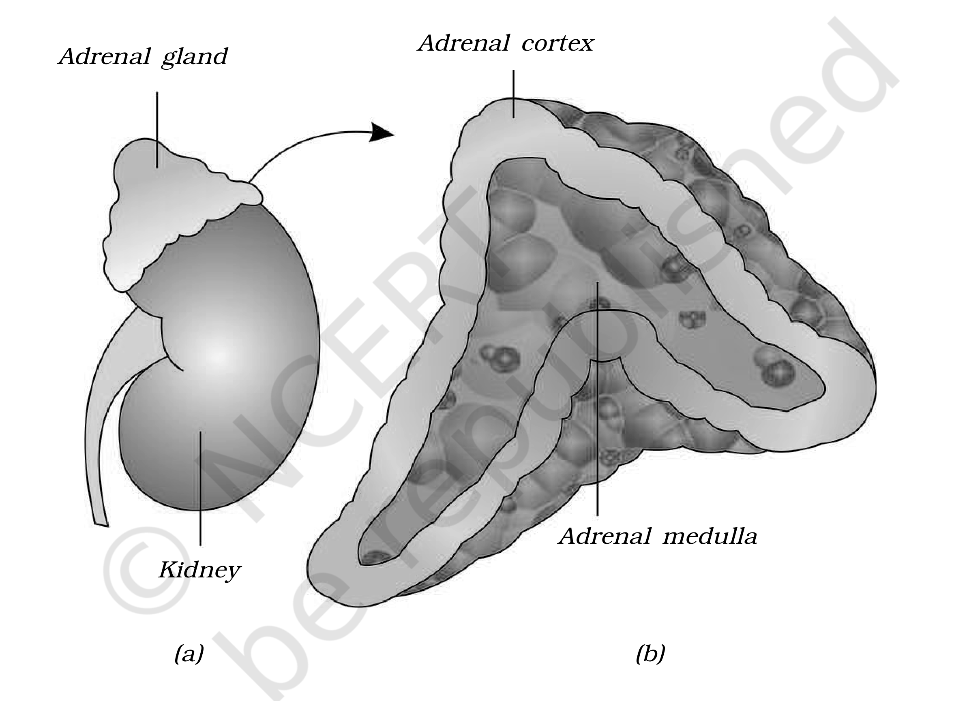
Figure 19.4 Diagrammatic representation of : (a) Adrenal gland above kidney (b) Section showing two parts of adrenal gland
[NOTE] Underproduction of hormones by the adrenal cortex alters carbohydrate metabolism, causing acute weakness and fatigue, leading to a disease called Addison's disease.

Medulla | Adrenal medulla - the catecholamines

• The adrenal medulla secretes two hormones called adrenaline or epinephrine and noradrenaline or norepinephrine. These are commonly called as catecholamines.
Adrenaline and noradrenaline are rapidly secreted in response to stress of any kind and during emergency situations and are called emergency hormones or hormones of Fight or Flight.
Catecholamine effect | What happens
Alertness and skin | These hormones increase alertness, pupilary dilation (the source's own spelling), piloerection (raising of hairs), sweating etc.
Heart and lungs | Both the hormones increase the heart beat, the strength of heart contraction and the rate of respiration
Carbohydrate | Catecholamines stimulate the breakdown of glycogen resulting in an increased concentration of glucose in blood
Fat and protein | In addition, they also stimulate the breakdown of lipids and proteins

[NOTE] The one-line list to reproduce in an exam: these hormones increase alertness, pupilary dilation, piloerection, sweating, heart beat, strength of heart contraction, rate of respiration, glycogenolysis, lipolysis, proteolysis. The last three are the metabolic names for the breakdown of glycogen, lipids and proteins above.

Cortex | Adrenal cortex - the corticoids

The adrenal cortex can be divided into three layers, called zona reticularis (inner layer), zona fasciculata (middle layer) and zona glomerulosa (outer layer). The adrenal cortex secretes many hormones, commonly called as corticoids.
Corticoid class | Definition | Main one in our body
Glucocorticoids | The corticoids involved in carbohydrate metabolism | Cortisol is the main glucocorticoid
Mineralocorticoids | Corticoids which regulate the balance of water and electrolytes in our body | Aldosterone is the main mineralocorticoid in our body

• Glucocorticoids stimulate gluconeogenesis, lipolysis and proteolysis; and inhibit cellular uptake and utilisation of amino acids.
• Cortisol is also involved in maintaining the cardio-vascular system as well as the kidney functions.
• Glucocorticoids, particularly cortisol, produce anti-inflammatory reactions and suppress the immune response.
• Cortisol stimulates the RBC production.
• Collected in one line: glucocorticoids stimulate gluconeogenesis, lipolysis, proteolysis, erythropoiesis, cardio-vascular system, blood pressure, and glomerular filtration rate, and inhibit inflammatory reactions by suppressing the immune response.
1 | Aldosterone acts mainly at the renal tubules.
2 | It stimulates the reabsorption of Na⁺ and water.
3 | It stimulates the excretion of K⁺ and phosphate ions.
4 | Thus aldosterone helps in the maintenance of electrolytes, body fluid volume, osmotic pressure and blood pressure.

[NOTE] Small amounts of androgenic steroids are also secreted by the adrenal cortex, which play a role in the growth of axial hair, pubic hair and facial hair during puberty.

[MEMORY AID - not in NCERT] Cortex from outside in - "salt, sugar, sex": zona glomerulosa (outer) is the salt layer, zona fasciculata (middle) the sugar layer, zona reticularis (inner) the sex-steroid layer. NCERT lists them inner-first, so read the list backwards.

19.2.8 | Pancreas

Pancreas is a composite gland (Figure 19.1) which acts as both exocrine and endocrine gland.
• The endocrine pancreas consists of 'Islets of Langerhans'. There are about 1 to 2 million Islets of Langerhans in a normal human pancreas, representing only 1 to 2 per cent of the pancreatic tissue.
Islet cell | Hormone | Chemical nature
alpha-cells | Glucagon | Peptide hormone; plays an important role in maintaining the normal blood glucose levels
beta-cells | Insulin | Peptide hormone; plays a major role in the regulation of glucose homeostasis

[NOTE] The source prints these two cell names with the Greek letters alpha and beta before the word cells; they are spelled out here so the page stays a plain-ASCII print file. The two main types of cells in the Islet of Langerhans are exactly these two.

Glucagon - the hyperglycemic hormone
1 | Glucagon acts mainly on the liver cells (hepatocytes).
2 | It stimulates glycogenolysis, resulting in an increased blood sugar (hyperglycemia).
3 | In addition, this hormone stimulates the process of gluconeogenesis, which also contributes to hyperglycemia.
4 | Glucagon reduces the cellular glucose uptake and utilisation.
5 | Thus, glucagon is a hyperglycemic hormone.

Insulin - the hypoglycemic hormone
1 | Insulin acts mainly on hepatocytes and adipocytes (cells of adipose tissue).
2 | It enhances cellular glucose uptake and utilisation.
3 | As a result, there is a rapid movement of glucose from blood to hepatocytes and adipocytes, resulting in decreased blood glucose levels (hypoglycemia).
4 | Insulin also stimulates conversion of glucose to glycogen (glycogenesis) in the target cells.

• The glucose homeostasis in blood is thus maintained jointly by the two - insulin and glucagons (the source's own plural spelling of glucagon).
[NOTE] Prolonged hyperglycemia leads to a complex disorder called diabetes mellitus, which is associated with loss of glucose through urine and formation of harmful compounds known as ketone bodies. Insulin deficiency and/or insulin resistance result in this disease, and diabetic patients are successfully treated with insulin therapy.

[MEMORY AID - not in NCERT] Alphabet trick: Alpha comes first and gives glucAgon, which raises sugar; Beta gives insulin, which Brings sugar down. Hyper- and hypo-glycemia are therefore alpha and beta respectively.

19.2.9 | Testis

A pair of testis is present in the scrotal sac (outside abdomen) of male individuals (Figure 19.1). Testis performs dual functions as a primary sex organ as well as an endocrine gland.
• Testis is composed of seminiferous tubules and stromal or interstitial tissue. The Leydig cells or interstitial cells, which are present in the intertubular spaces, produce a group of hormones called androgens, mainly testosterone.
• Androgens regulate the development, maturation and functions of the male accessory sex organs like epididymis, vas deferens, seminal vesicles, prostate gland, urethra etc.
• These hormones stimulate muscular growth, growth of facial and axillary hair, aggressiveness, low pitch of voice etc.
• Androgens play a major stimulatory role in the process of spermatogenesis (formation of spermatozoa).
• Androgens act on the central neural system and influence the male sexual behaviour (libido).
• These hormones produce anabolic (synthetic) effects on protein and carbohydrate metabolism.
• Collected in one line: the testis secretes androgens, which stimulate the development, maturation and functions of the male accessory sex organs, appearance of the male secondary sex characters, spermatogenesis, male sexual behaviour, anabolic pathways and erythropoiesis.
19.2.10 | Ovary

Females have a pair of ovaries located in the abdomen (Figure 19.1). Ovary is the primary female sex organ which produces one ovum during each menstrual cycle. In addition, ovary also produces two groups of steroid hormones called estrogen and progesterone.
• Ovary is composed of ovarian follicles and stromal tissues. The estrogen is synthesised and secreted mainly by the growing ovarian follicles.
1 | (cycle - last step feeds back to step 1)
2 | A follicle grows and secretes estrogen.
3 | Ovulation occurs.
4 | After ovulation, the ruptured follicle is converted to a structure called corpus luteum.
5 | The corpus luteum secretes mainly progesterone.

Hormone | Actions
Estrogens | Produce wide ranging actions such as stimulation of growth and activities of female secondary sex organs, development of growing ovarian follicles, appearance of female secondary sex characters (e.g., high pitch of voice, etc.) and mammary gland development. Estrogens also regulate female sexual behaviour
Progesterone - the exercises call it the Progestational hormone | Progesterone supports pregnancy. It also acts on the mammary glands and stimulates the formation of alveoli (sac-like structures which store milk) and milk secretion. Progesterone thus plays a major role in the maintenance of pregnancy as well as in mammary gland development and lactation

19.3 | HORMONES OF HEART, KIDNEY AND GASTROINTESTINAL TRACT

Hormones are also secreted by some tissues which are not endocrine glands.
Non-gland source | Hormone | Action
Heart - the atrial wall | Atrial natriuretic factor (ANF), a very important peptide hormone | Decreases blood pressure
Kidney - the juxtaglomerular cells | Erythropoietin, a peptide hormone | Stimulates erythropoiesis (formation of RBC)

1 | Blood pressure is increased.
2 | ANF is secreted.
3 | This causes dilation of the blood vessels.
4 | This reduces the blood pressure.

• Endocrine cells present in different parts of the gastro-intestinal tract secrete four major peptide hormones, namely gastrin, secretin, cholecystokinin (CCK) and gastric inhibitory peptide (GIP).
GI hormone | Acts on | Action
Gastrin | The gastric glands | Stimulates the secretion of hydrochloric acid and pepsinogen
Secretin | The exocrine pancreas | Stimulates secretion of water and bicarbonate ions
CCK | Both pancreas and gall bladder | Stimulates the secretion of pancreatic enzymes and bile juice, respectively
GIP | The stomach | Inhibits gastric secretion and motility

[NOTE] Taken together, these hormones regulate the secretion of digestive juices and help in digestion - three stimulate a secretion and the fourth, GIP, shuts one down.

Several other non-endocrine tissues secrete hormones called growth factors. These factors are essential for the normal growth of tissues and their repairing/regeneration.
[MEMORY AID - not in NCERT] Four GI hormones, three organs, one inhibitor: Gastrin -> stomach acid, Secretin -> pancreatic bicarbonate, CCK -> pancreatic enzymes + bile, GIP -> the only one that inhibits. "GIP is the Grumpy Inhibitory Peptide."

19.4 | MECHANISM OF HORMONE ACTION

Hormones produce their effects on target tissues by binding to specific proteins called hormone receptors located in the target tissues only.
Receptor class | Where it sits
Membrane-bound receptors | Hormone receptors present on the cell membrane of the target cells
Intracellular receptors | Receptors present inside the target cell, mostly nuclear receptors (present in the nucleus)

1 | Binding of a hormone to its receptor leads to the formation of a hormone-receptor complex (Figure 19.5 a, b).
2 | Each receptor is specific to one hormone only and hence receptors are specific.
3 | Hormone-Receptor complex formation leads to certain biochemical changes in the target tissue.
4 | Target tissue metabolism and hence physiological functions are regulated by hormones.

On the basis of their chemical nature, hormones can be divided into groups :
Group | Examples
(i) peptide, polypeptide, protein hormones | e.g., insulin, glucagon, pituitary hormones, hypothalamic hormones, etc.
(ii) steroids | e.g., cortisol, testosterone, estradiol and progesterone
(iii) iodothyronines | thyroid hormones
(iv) amino-acid derivatives | e.g., epinephrine

Receptor used | Does the hormone enter the cell? | What it regulates
Membrane-bound | Normally do not enter the target cell, but generate second messengers (e.g., cyclic AMP, IP₃, Ca⁺⁺ etc) | The second messengers in turn regulate cellular metabolism (Figure 19.5a)
Intracellular (e.g., steroid hormones, iodothyronines, etc.) | Enter and bind inside the cell | Mostly regulate gene expression or chromosome function by the interaction of hormone-receptor complex with the genome

[NOTE] Cumulative biochemical actions result in physiological and developmental effects (Figure 19.5b) - which is why a single hormone-receptor binding event can end in tissue growth.

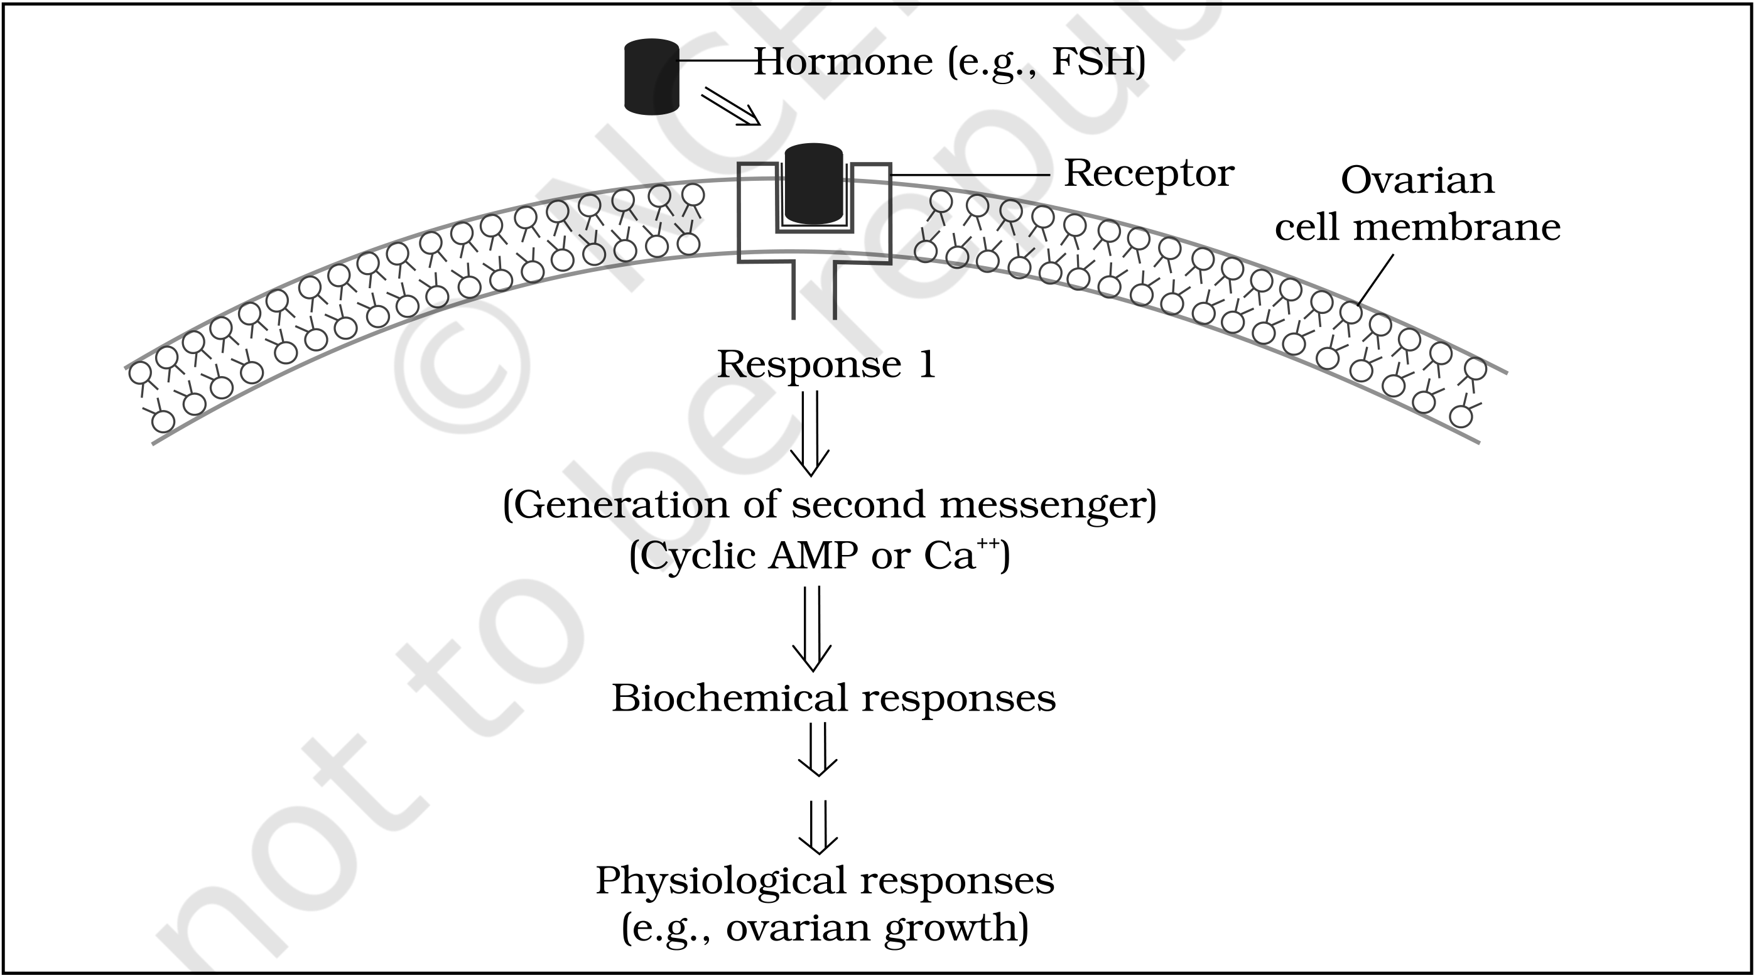
Figure 19.5 Diagramatic representation of the mechanism of hormone action : (a) Protein hormone
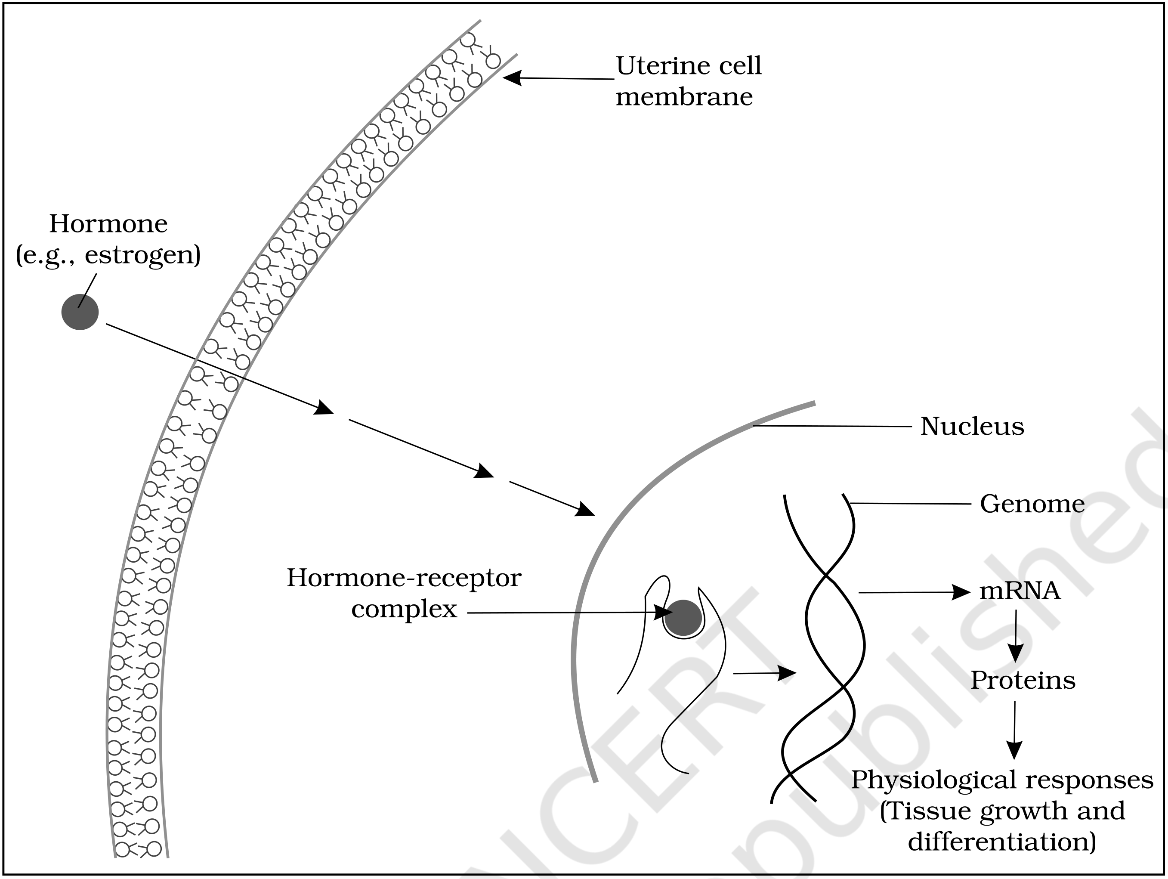
Figure 19.5 Diagramatic representation of the mechanism of hormone action : (b) Steroid hormone
[MEMORY AID - not in NCERT] Two mechanisms, one question: does the hormone get in? Protein/peptide hormones stay outside and shout through a second messenger; steroids and iodothyronines walk in and talk to the genome. Water-soluble stays out, lipid-soluble goes in.

Recap | Quick recap of the whole chapter

• There are special chemicals which act as hormones and provide chemical coordination, integration and regulation in the human body; they regulate metabolism, growth and development of our organs.
• The endocrine system is composed of hypothalamus, pituitary and pineal, thyroid, adrenal, pancreas, parathyroid, thymus and gonads; gastrointestinal tract, kidney and heart also produce hormones.
• Pituitary: pars distalis produces six trophic hormones; pars intermedia secretes only one; pars nervosa secretes two. The pituitary hormones regulate somatic tissue growth and peripheral endocrine glands.
• Pineal: melatonin governs the 24-hour (diurnal) rhythm - sleep and waking, body temperature.
• Thyroid: BMR, central neural system maturation, erythropoiesis, carbohydrate/protein/fat metabolism, menstrual cycle; thyrocalcitonin lowers blood calcium. Parathyroid: PTH raises it.
• Thymus: thymosins differentiate T-lymphocytes (cell-mediated immunity) and raise antibody production (humoral immunity).
• Adrenal: medulla secretes epinephrine and norepinephrine; cortex secretes glucocorticoids and mineralocorticoids.
• Pancreas: glucagon raises blood glucose (glycogenolysis, gluconeogenesis); insulin lowers it (uptake, utilisation, glycogenesis). Failure of insulin gives diabetes mellitus.
• Gonads: testis secretes androgens; ovary secretes estrogen and progesterone.
• Non-glands: ANF from the heart lowers blood pressure, erythropoietin from the kidney drives RBC formation, and the gastrointestinal tract secretes gastrin, secretin, cholecystokinin and gastric inhibitory peptide.
Appendix | Terms the exercises use, and where they are answered

Term as the exercises print it | This chapter's own wording | Section
Exocrine gland | The chapter defines the endocrine gland as ductless; the exocrine gland is therefore the duct-bearing kind. Stated as an addition - the chapter never defines it | 19.1
Atrium | The body says atrial wall of the heart (ANF) | 19.3
G-I Tract | The body says gastro-intestinal tract | 19.3
Hypoglycemic / hyperglycemic hormone | The body uses the nouns hypoglycemia (insulin) and hyperglycemia (glucagon) | 19.2.8
Gonadotrophic hormones | LH and FSH stimulate gonadal activity and hence are called gonadotrophins | 19.2.2
Blood pressure lowering hormone | ANF decreases blood pressure | 19.3
Thyrotrophin, Corticotrophin, Melanotrophin, Progestational hormone | TSH, ACTH, MSH and progesterone - the only place the book prints these four names is the exercise list | 19.2.2, 19.2.10
Mechanism of action of FSH | The membrane-bound receptor plus second messenger route, drawn with Hormone (e.g., FSH) in Figure 19.5a | 19.4

[NOTE] The textbook's final page carries only the word NOTE above a blank panel and the reprint line - it holds no biology, so nothing from it is reproduced here.

